Name:

SALT: FL Aquaculture Commodities “Alligator Farming”
In this week’s segment we will learn more about alligator farming! Each day there will be an assigned reading and activity worksheet to be completed.

Day 1: Let’s Talk About Alligators (handout)

Day 2: Alligator Production: Breeding and Egg Incubation (SRAC 231) Day 3: Alligator Production: Grow-out and Harvest (SRAC 232)
Day 4: Alligator and Reptile Culture Presentation (handout)

Day 5: Gatorama Tour by Allen Register *

* If internet access is available, recorded video tours can be viewed via YouTube.
Name:

SALT: FL Aquaculture Commodities “Alligator Farming”

Day 1: In today’s lesson we will be reading through the Let’s Talk About Alligator handout. Once you are finished, you may use the reading to answer the Gator Body: External and Internal Functions questions below.

Gator Body: External and Internal Functions

Check the correct descriptions about alligators’ internal and external bodies.
INTERNAL FUNCTIONS
EXTERNAL FUNCTIONS

- Alligators have a
3-chambered heart.

- Alligators have large brains.
- They breathe using a better functioning respiratory system, including stronger lungs, and lack gills.
- They need to eat at least three times a day.

- They cannot generate their own body heat and must modify their activity to regulate their internal temperature.
- They have internal “copulatory organs” for fertilization.
- Alligators shed tears.
- Alligators have complete 360 vision.

- Alligators have up to 80 teeth.

- Their epidermis is covered in keratin scales.

- Their tails are meant to whip prey when hunting

- Their jaw structures are built for crushing prey

- Most reptiles lay
hard-shelled amniotic eggs

- They have limbs with five toes for movement

- They chew their food.
- Alligators shed their skin.
- All alligators live in saltwater environments.

Name:

SALT: FL Aquaculture Commodities “Alligator Farming”

Day 2: In today’s lesson we will be reading Alligator Production: Breeding and Egg Incubation (SRAC 231) . Once you are finished, you may use the reading to answer the questions below.

- What are the 3 phases of commercial alligator production?

- True or False: In Louisiana, Florida, and Texas licensed Alligator farms can collect eggs (not hatchlings) from the wild during the nesting season to be hatched on farms.

- Describe the courtship rituals of the alligator. Include time of year.

- Describe and draw a picture of what an alligator nest looks like.

- The method and timing of alligator egg collection is very important. Describe how you would collect eggs from the wild if you were an alligator farmer? What are the advantages of your process for collecting eggs? What precautions will you take during collection?

- Incubation temperature is critical to the survival and development of the eggs. It also determines the sex of the hatchling. Fill in the blanks:

Temperatures of °F and below produce all females. Temperatures of 91°F and above produce all .
Most alligator farmers incubate eggs at °F to °F.
Name:

SALT: FL Aquaculture Commodities “Alligator Farming”

Day 3: In today’s lesson we will be reading Alligator Production: Grow-out and Harvest (SRAC 232). Once you are finished, you may use the reading to answer the questions below.

- Fill in the blanks for the recommended pen sizes for growout operations.

Gator Length | Pen Size Length x width (ft) | Gators per pen | Square ft per gator
7 – 15 in |  | 20
 | 10x12
30 in – 4 ft |  |  | 3.36
 | 12x16 | 50
 |  | 40

- What are the commonly used stocking regime for alligators? Fill in the blanks.

  - square foot per animal until 2 feet in length
  - 3 square feet per animal for feet in length
  - square feet per animal for 4-6 feet in length

- What are examples of signs you may observe if an alligator is stressed?

- What two antibiotics can be added to feed when bacterial problems occur?

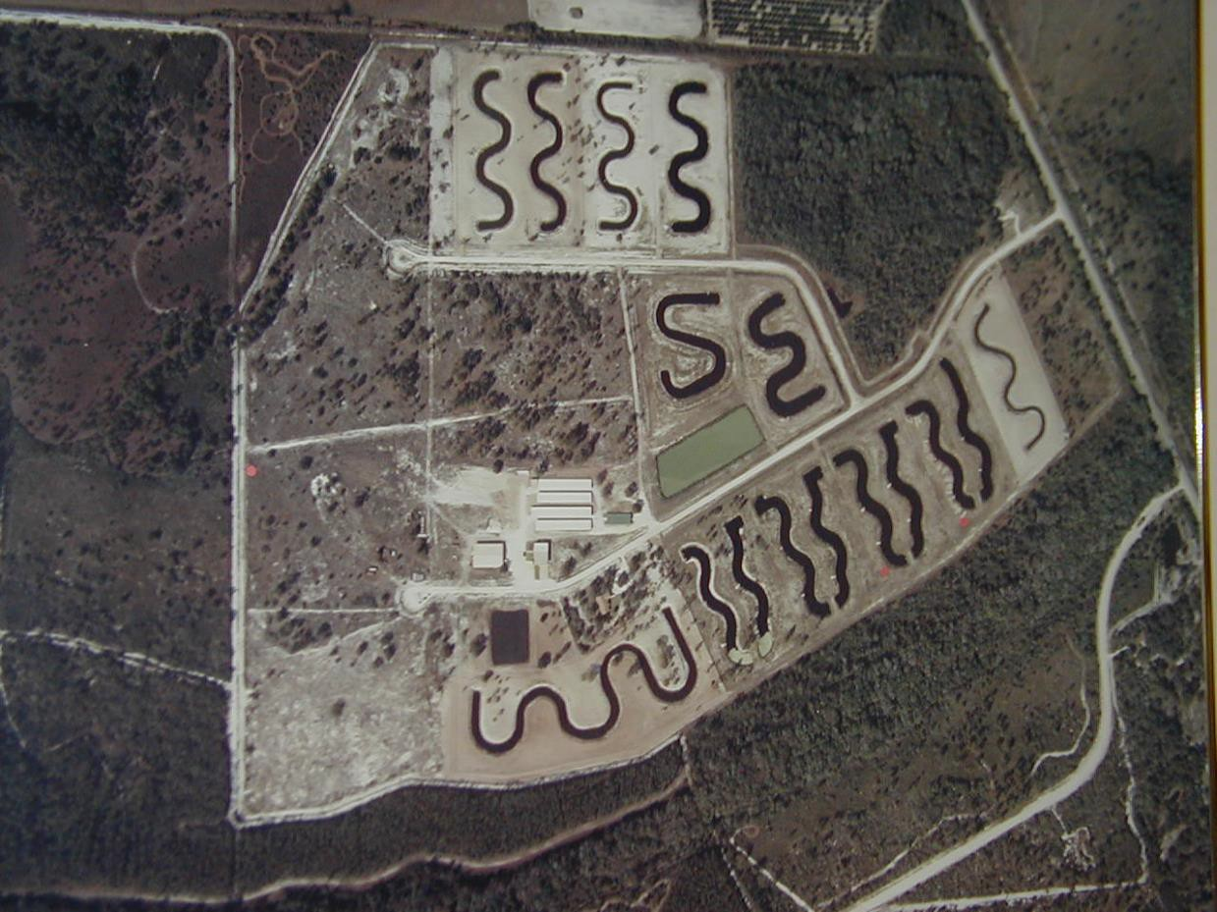
- Looking at the aerial photo of an outdoor alligator farm, why do you think alligator ponds are curvy?

- In the past, most alligator farms were equipped with large walkin freezers to store what types of alligator feeds?

- Today, many alligator farms use artificial diets for feed. What are the benefits of using artificial feed?

- What is the minimum harvest size of an alligator? How long does it typically take for an alligator to reach the minimum harvest size?

Name:

SALT: FL Aquaculture Commodities “Alligator Farming”

Day 4: In today’s lesson we will be reading Alligator and Reptile Culture Presentation (handout). Once you are finished, you may use the reading to answer the questions below.

- What is the species name of the American Alligator?

- Name 3 ways to tell an alligator and crocodile apart?

- Identify whether each photo is an alligator or crocodile?

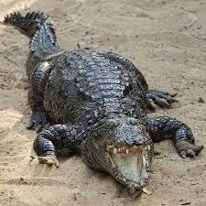
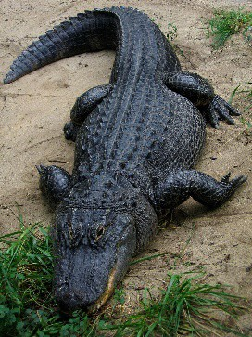
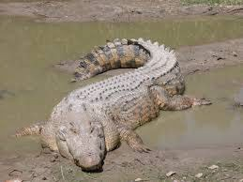
  - b) c)

- What type of habitat do alligators like to live in?

- What is the American Alligator’s range in the United States? What limits the alligators’ northern geographical range?

- Are alligators classified as threatened or endangered in Florida? Explain.

- Where was the first commercial alligator farm in Florida?

Name:

SALT: FL Aquaculture Commodities “Alligator Farming”

Day 5: In today’s lesson we will be watching the Gatorama Tour by Allen Register. You can watch the video via YouTube by visiting https://youtu.be/UUvJSPPXQQc (Tour Starts at 48:00 / 1:08:29). Once you are finished, answer the questions below.

- Did you learn anything new from the Gatorama Tour?

- What was your favorite part of the tour?

- Describe how helicopters are used to locate alligator nests?

- Was Allen Register able to answer all your questions? If not, what questions would you like to ask him?

- How many fingers does Allen Register (alligator farmer) have?

