Name:

SALT: FL Aquaculture Commodities

“Ornamental fish Culture”
In this week’s segment we will learn more about farming ornamental fish! Each day there will be an assigned reading and activity worksheet to be completed.

Day 1: Freshwater Ornamental Fish Commonly Cultured in Florida
(UF handout)

Day 2: Use of Antibiotics in Ornamental Fish Aquaculture (UF handout)
Day 3: Ornamental Fish Culture (UF handout)
Day 4: Angelfish Facts and Clownfish Facts (handouts)
Day 5: Ornamental Fish Culture Tour by Eric Cassiano *

*Video Tours If internet access is available
To view the recorded Ornamental Fish Culture video tour, go to:
1) YouTube.com and search “2018_SALT_Ornamental Fish Culture”
OR
2) Open internet browser, type https://youtu.be/Vhp4UTp0f1M in the address bar

SALT: FL Aquaculture Commodities

“Ornamental fish Culture”

Day 1: In today’s lesson we will be reading Freshwater Ornamental Fish Commonly Cultured in Florida (handout). Once you are finished, you may use the reading to answer the questions below.

- Florida’s tropical ornamental aquaculture industry is concentrated in what three counties?

- Order the Hierarchy of Taxonomic Groupings 1-8, with 1 being the largest grouping and 8 being the smallest grouping.

Number 1-8 | Taxonomic Grouping
 | Class
 | Tribe
 | Family
 | Phylum
 | Genus
 | Kingdom
 | Order
 | Species

- The family Cyprinidae consists of how many species of fish? How many genera?

- Describe how tetras breed? Is there parental care?

- How do Corydoras breath air?

- Where do plecos typically breed in the wild?

- What does the rainbowfishes diet typically consist of?

- Match the common ornamental fish group name with its family name.
Common Group Name | Answer | Family
- Tetras/Characins | _____ | - Loricariidae
- Armored Catfish/Corydoras Catfish | _____ | - Poeciliidae
- Livebearers | _____ | - Characidae
- Cichlids | _____ | - Melanotaeniidae, Pseudomugilidae
- Suckermouth Armored Catfish/Plecos | _____ | - Osphronemidae and Helostomatidae
- Labyrinth Fish | _____ | - Callichthyidae
- Rainbowfishes | _____ | - Cichlidae

Name:

SALT: FL Aquaculture Commodities

“Ornamental fish Culture”

Day 2: In today’s lesson we will be reading Use of Antibiotics in Ornamental Fish Aquaculture. Once you are finished, you may use the reading to answer the questions below.

- Can antibiotics cure a fish? Explain.

- Gram-positive and gram-negative bacteria stain different colors because they have different cell wall structures. What color does a gram-positive bacteria stain and gram-negative bacteria stain?

- What major group of gram-positive bacteria cause disease in fish?

- What factors can cause a fish to be stressed?

- What is pharmacokinetics?

- What does the term ‘shot-gunning” mean when administering antibiotics?

- Match the major routes of antibiotic administration with the correct description. Some terms may have more than 1 correct description.

Administration Type | Answer | Description
- Injection | _____ | - Most cost effective and commonly used method to deliver antibiotics
- Mixed in food | _____ | - Not recommended in recirculating systems or in any aquarium system where the treated water will contact the biological filter
- Bath treatments | _____ | - When the majority of the fish are not eating or when treating primarily external bacterial infections
- Most direct and effective method
For getting antibiotics into the blood stream
 |  | - The proper dose of antibiotic is mixed into the feed during production
 |  | - Very labor intensive and impractical for fish grown on a commercial scale

Name:

SALT: SALT: FL Aquaculture Commodities

“Ornamental fish Culture”

Day 3: In today’s lesson we will be reading the Ornamental Fish Culture (handout). Once you are finished, you may use the reading to answer the questions below.

- If you grow tropical fish at home and plan to barter, sell, or trade your fish what certificate so you need?

- List two reasons Florida is one of the largest ornamental producers in the nation?

- Ornamental Fish are divided into 3 main groups for culturing methods. What are the three groups? Give one example of fish for each group.

- Describe how acrylic traps are used to harvest fish?

- Fish are sold in full and half bag lots. What are the dimensions of a full size and half size bag?

- List three types of food that can be fed to ornamental fish.

- Describe how clownfish spawn and parent?

- Match the term with the correct description.
Term | Answer | Description
- Slate | _____ | - Adults hold their eggs and live young in their mouths until they are large enough to swim freely
- MS-222 | _____ | - Angelfish need to lay their adhesive eggs on what type of surface
- Muskgrass | _____ | - Fish reproduce by internal fertilization and internal embryonic development
- Mouthbrooder | _____ | - Only sedative approved for use in some species of fish
- Artemia | _____ | - Fed to Clownfish when hatched
- Live-bearer | _____ | - Aquatic plant is a pest to ornamental fish pond culture
- Rotifers | _____ | - Commonly fed to freshwater ornamentals
- Live Rock | _____ | - Simply porous rock, often limestone, that is cured in a marine environment

Name:

SALT: FL Aquaculture Commodities

“Ornamental fish Culture”

Day 4: In today’s lesson we will be reading the Angelfish Facts and Clownfish Facts (handouts). Once you are finished, you may use the readings to answer the questions below.

- List three popular color variations of freshwater angelfish

- How large do marine angelfish get compared to freshwater angelfish?

- Describe the reproduction of angelfish.

- Ich is a parasitic condition that sometimes affects pet fish. What stressors might cause ich to occur?

- How can you distinguish an Orange Skunk Clownfish from a Clarkii Clownfish?

- Describe the symbiotic relationship Clownfish have with anemones.


- Label each part of the angelfish: Crown, Eye Stripe, Gil Cover, Ventral Fin, Pectoral Fin, Dorsal Fin, Caudal Peduncle, Caudal Filament, Caudal Fin, And Anal Fin. Hint: Refer to the Ornamental Fish Culture Handout.

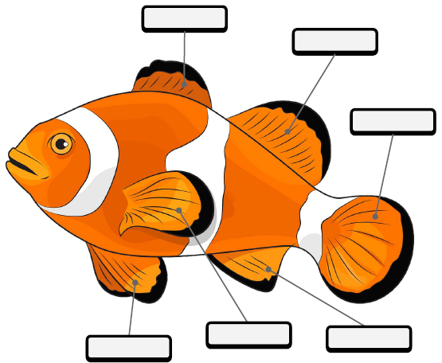
- Label each part of the angelfish: Adipose Fin, Dorsal Fin, Caudal Fin, Ventral Fin, Anal Fin, and Pectoral Fin.

Name:

SALT: FL Aquaculture Commodities

“Ornamental fish Culture”

Day 5: In today’s lesson we will be watching the Ornamental Fish Culture Tour by Eric Cassiano. You can watch the video via YouTube by visiting https://youtu.be/Vhp4UTp0f1M (Tour Starts at 45:00 / 57:38). Once you are finished, answer the questions below.

- Did you learn anything new from the Ornamental Fish Culture Tour?

- What was your favorite part of the tour?

- Was Eric Cassiano able to answer all your questions? If not, what questions would you like to ask him?

- What are the four areas pf research that take place at the UF/IFAS Tropical Aquaculture Lab in Ruskin, FL ?

- How many ponds, acres, and greenhouses does the UF/IFAS Tropical Aquaculture Lab in Ruskin, FL have?

- You have been tasked with designing an ornamental fish tank. What is your vision for the tank? Be creative. Stuck? Use this week’s handouts for ideas. Be sure to include:
  - Which fish species you plan to stock the tank with? Why?
  - Will you add any aquatic plants or fish habitat? Why?
  - What will you feed the fish?
  - What water quality parameters will you monitor?

